**Key Stages in Cloud Resource Scheduling using FL & RL**

Cloud computing requires efficient resource scheduling to ensure that tasks are allocated properly, minimizing costs and improving performance. Traditional scheduling methods struggle to adapt dynamically, but Federated Learning (FL) and Reinforcement Learning (RL) solve this problem by optimizing task distribution in real-time.

These services operate at three levels: IaaS, PaaS, and SaaS.

IaaS (Infrastructure as a Service) provides virtual machines, storage, and computing power—the foundation where all scheduling happens.

PaaS (Platform as a Service) offers a development environment where scheduling models using FL and RL can be deployed.

SaaS (Software as a Service) runs user-facing applications like Netflix and cloud gaming, which rely on efficient scheduling for smooth performance.

There are five key stages in this process:

1. Federated Model Training

One of the major challenges in cloud scheduling is that sending large amounts of raw data to a central cloud for processing leads to high network costs, privacy concerns, and delays.

How FL solves this:

Instead of transmitting raw data to a centralized server, FL trains models directly on cloud nodes (or edge devices) and only shares model updates.

This means each cloud node learns from its own local workload patterns, and only the improved AI model is sent to the central cloud, reducing network congestion.

This approach cuts down data transmission costs while ensuring faster model training.

Example:

In Netflix’s global infrastructure, each regional data center (e.g., in Mumbai, New York, and London) learns local user preferences for video streaming (like buffering rates, resolution choices, and peak streaming hours). Instead of sharing user data, the trained model from each region is sent to the central Netflix AI system, which then updates the global scheduling model for improved efficiency.

🔹 Benefit: This enables faster and more adaptive scheduling while keeping data secure.

---

2. Dynamic Scheduling via RL

Once FL has trained an initial model, Reinforcement Learning (RL) takes over to dynamically adjust task scheduling based on real-time conditions.

How RL improves scheduling:

RL observes system workload and learns from past scheduling decisions to make better choices in the future.

It continuously adjusts the task allocation strategy to balance processing speed, energy efficiency, and server load.

Example:

If Netflix suddenly sees a 50% increase in streaming traffic due to a new movie release, RL will detect the demand spike and allocate more cloud resources automatically.It will move users to less crowded servers in nearby locations, ensuring a smooth streaming experience without buffering.

🔹 Benefit: Unlike traditional scheduling, RL adapts in real-time, preventing overloading of cloud resources.

---

3. Cost-Effective Task Assignment

Cloud services need to reduce costs by efficiently assigning tasks to the right servers while maintaining high performance.

How FL & RL help:

FL allows regional cloud nodes to make scheduling decisions independently, reducing reliance on costly centralized data centers.

RL learns cost-efficient scheduling strategies, like choosing low-energy consumption servers or assigning non-urgent tasks to off-peak hours when cloud computing costs are lower.

Example:

A company running machine learning model training on Google Cloud uses RL to schedule training tasks at night, when electricity prices are lower. This reduces operational costs without affecting model performance.

🔹 Benefit: The system saves money by allocating tasks more intelligently.

---

4. Improved Task Completion Times

A major challenge in cloud computing is delays caused by inefficient scheduling.

How FL & RL reduce task completion time:

FL allows distributed cloud nodes to pre-process tasks locally, rather than waiting for instructions from a central cloud.

RL prioritizes urgent tasks and assigns them to the fastest available cloud resources.

Example:

Cloud gaming services like NVIDIA GeForce Now use Reinforcement Learning (RL) to efficiently allocate GPU resources. When a player finishes their session, RL instantly assigns the freed GPU to the next waiting user. It also predicts which GPUs will be available soon, reducing waiting time and ensuring smooth gameplay without delays.

🔹 Benefit: Faster execution of cloud tasks, improving overall system performance.

---

5. Seamless Scalability

Cloud workloads fluctuate—for example, an e-commerce site needs more cloud resources during a sale but fewer after it ends.

How FL & RL improve scalability:

FL allows each cloud region to predict its own demand and scale resources before a bottleneck occurs.

RL ensures automatic scaling, meaning more servers are added or removed based on demand.

Example:

During Amazon’s Great Indian Festival sale, AWS cloud services auto-scale to handle increased traffic. RL monitors the demand in real-time and ensures only the necessary number of servers are used, avoiding waste.

🔹 Benefit: Cloud resources scale up or down efficiently, preventing system crashes.

**Mathematical Formulation of Cloud Scheduling**

To optimize scheduling, we define the objective function:

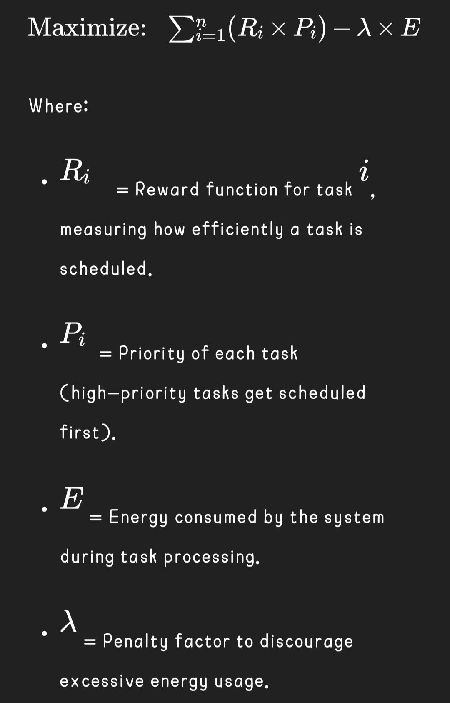

Why this is important:

* The goal is to maximize task efficiency while minimizing energy consumption.
* This function ensures smart task allocation without overloading servers.

Example:

*If a Google Cloud server has limited resources, the function ensures that high-priority tasks (like real-time video processing) get scheduled first, while less urgent tasks (like data backup) are scheduled during off-peak hours.*

This equation ensures that the system optimizes performance while minimizing power consumption, making cloud resource scheduling more efficient.